**Difference between JPA, Hibernate & Spring Data JPA**

**Java Persistence API(JPA)**

* It is a standard specification (JSR 338) for ORM in Java.
* Its objective is to define how Java objects map to database tables.
* It is only an interface/ standard with no implementation.
* Popular Implementations include: Hibernate, EclipseLink, OpenJPA.

**Hibernate**

* It is a popular implementation of JPA.
* Its objective is to provide the actual functionality for the JPA specification.
* Includes features beyond JPA like caching, filters, etc.
* Requires manual transaction management and session handling.

Example:

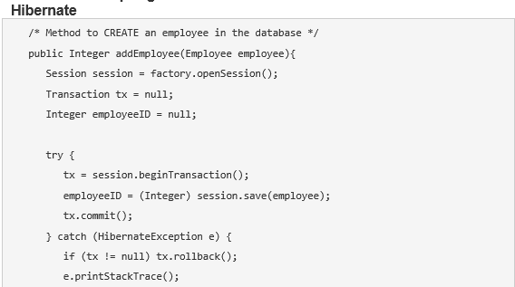

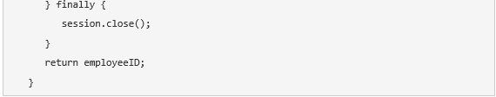

**Spring Data JPA**

* It is a Spring module that simplifies data access using JPA.
* Its objective is to eliminate boilerplate DAO code.
* It uses interfaces like JpaRepository, CrudRepository.
* It can work with any JPA provider (usually Hibernate).
* It also adds derived queries, paging, sorting, transactions.

Example:

The Java Persistence API provides a specification for persisting, reading, and managing data from your Java object to relational tables in the database.

Hibernate is a JPA implementation, while Spring Data JPA is a JPA Data Access Abstraction.